Neurodiversity at the Workplace

# Table of Contents

Table of Contents 1

What is Neurodiversity? 1

Terminology 1

Prevalence 1

Neurodiversity and You 2

Getting Help 2

Accommodations 3

Getting a Diagnosis 6

If your disability is invisible 6

When to disclose 6

Neurodiversity in the Workplace 7

Challenges 7

Benefits 8

Taking Care of Neurodivergent Colleagues 8

What is Disability? 9

Taking Care of Everybody 9

Invisibility of Disability 10

Lack of Knowledge 10

Masking 10

Nature of the Condition 10

Stereotypes 11

Stigma 11

Practical Advice 11

Sources 12

Books 13

Unsorted Information 14

# What is Neurodiversity?

We are all different, and neurodiversity is yet another aspect of variation between people. It “describes the idea that people experience and interact with the world around them in many different ways. [1]”

## Terminology

**Spectrum** (noun)  
Neurological differences or disorders are said to be a “spectrum”, acknowledging that they can vastly differ in severity or expression from non-existent to very strong.  
  
**Neurodiversity** (noun)  
The range of differences in individual brain function and behavioral traits, regarded as part of normal variation in the human population. Neurodiversity can include Autism, ADHD, ADD, Dyslexia, Dyscalculia, Dyspraxia, and many more aspects.

**Neurodiverse** (adjective)  
A group having, relating to, or constituting a type of brain functioning that is not neurotypical.

**Neurodivergent** (noun)   
A person displaying or characterized by autistic or other neurologically atypical patterns of thought or behavior; not neurotypical.

**Neurotype** (noun)  
The different types of brain functions and behavioral traits, e.g. neurotypical, neurodivergent.

**Neurotypical** (adjective)  
Relating to or showing typical neurological behavior and development.

# Prevalence

Among the general population, about 15-20% are said to be neurodivergent [2]. However, neurodivergent people have a much higher unemployment rate (30-40% [3]), which is 3x higher compared to any other disability, and 8x higher compared to no disability. It is no surprise then that a UK-based *Diversity in Tech* report states that their interviewed employers estimate that 3% of their employees are neurodivergent. However, more than half(!) of the employees self-identify as neurodivergent when asked directly [4].

We can only guess what the numbers are for the eScience Center, but we can conclude that neurodiversity has a significant impact on our colleagues and the way we (would like to) work together.

# Neurodiversity and You

Suspecting or finding out that you are neurodivergent can be confusing or disorienting. Know that the “labels” of specific neurodivergences do not change who you are. While some find it comforting to accept a label (the struggle has a name now), others reject labels for themselves, especially when some still have stigmas attached to them. What *is* important – whether on a spectrum or not – are your needs. Disregarding whether you accept those labels or not, they can help you find out more about how your brain works and what you need to be balanced and productive.

You spent your whole life being you. The things *you* find typical, like the things you find easy or hard, might be perceived rather differently by your colleagues. This can be a sign of a need, either from you or others. Try identifying those needs.

You and your colleagues might have different approaches for getting certain tasks done. You need to be isolated, with a warm cup of tea and noise-cancelling headphones? Go for it. You need to be surrounded by colleagues that hold you accountable and spur you on? Try to organize this. There is no one, right way to be productive. Focus on the destination and find your own path.

## Getting Help

Whatever your challenges, you don’t have to face them alone. If you feel comfortable with it, speak with your team and line manager about it. You can anonymously approach the confidential advisors. Also consider asking a professional for help. While you are unique in your struggles, therapists will have met many others with comparable challenges and can help you in very targeted ways.

## Accommodations

If you need support to do your work (well), what reasonable accommodations are you entitled to? These are some examples from EU rules [5]:

* An on-site job coach for individuals with cognitive disabilities to help with training and task management.
* Job restructuring to redistribute marginal tasks that an employee with a disability cannot perform to other team members.
* Allowing telework or remote work for employees who have difficulty commuting or need a controlled environment due to sensory sensitivities.
* Modifying job responsibilities to focus on strengths and capabilities rather than limitations, such as assigning a visually impaired employee to a role that primarily involves auditory tasks.

While not legally binding for The Netherlands, the State of Ohio published a more detailed list [6]. We can take inspiration from it.

* Reasonable Accommodation Examples
  + Making the work environment accessible:
    - Relocate the workstation away from an open office space with distractions for an employee with sensory processing needs.
    - Install overhead LED lighting and lighting systems that permit adjustments to brightness for employees who are sensitive to standard lighting.
    - Permit adjustments to thermostats for employees with sensitivity to temperatures, such as intense heat.
    - Provide a fragrance-free environment for employees with sensory processing needs.
  + Restructuring a job:
    - Permit telework to avoid sensory sensitivities, reduce social demands, and improve concentration for work tasks.
    - Restructure essential functions to be supported with organized priorities, breaking large tasks into smaller steps, and clear guidelines for timelines.
    - Provide instructions in written, emailed, or recorded format for the employee to reference as needed.
    - Organize written communications by using bullet points instead of long paragraphs and section headers in documents.
  + Permitting a flexible schedule:
    - Reduce exposure to distractions like noise by permitting an employee to work flexible hours when fewer people are in the workplace.
    - Permit a later start time to avoid traveling during peak travel times that can be difficult with an employee with sensory processing needs.
    - Provide a modified break schedule to permit the employee to manage their needs during the workday, such as taking a break to call a family member for support or to have a movement break.
  + Altering or providing equipment or services:
    - Provide noise-cancelling headphones or earbuds to reduce the distraction of noise in the workplace.
    - Provide a second monitor to improve concentration on work tasks.
    - Provide assistive reading devices or services such as text to speech and screen reading software.
    - Provide speech to text software to assist with organizing thoughts into written documents.
    - Provide services and items to support viewing text on monitors such as screen filters, screen masks, tinting tools, and the ability to control font size, style, and contrast.
    - Provide devices and services that support memory such as digital recorders, digital timers, reminder apps on Smart devices, and a whiteboard.
    - Provide software and apps that supports literacy such as word prediction, spell checkers, and grammar.
    - Provide a mentor to provide guidance with navigating social interactions on the job, performing the job, and/or available resources such as employee benefits.
    - Permit the use of a job coach to provide structured training customized to the employee’s needs.
  + Altering supervisory methods:
    - Increase meeting frequency to provide feedback on work tasks.
    - Deliver instructions using plain language that is clear and concise and free of jargon and undefined technical terms.
    - Provide advanced notice of major changes at work, such as schedule changes or upcoming training sessions.
    - Provide meeting agendas in advance to enable an employee to manage stress by being prepared for the meeting.
    - Be prepared to provide information that is delivered in an audio format in a written format for employees with conditions that limit their auditory memory.
  + Modifying policies:
    - Modify a training policy to provide materials in advance of instruction.
    - Modify a training policy to permit additional time for onboarding to new work tasks.
    - Modify a training policy to permit the use of a job coach or additional training time when learning new tasks.
    - Modify a dress code to permit an employee with a tactile sensitivity to wear an alternative uniform.
* Here are examples of reasonable accommodations for the hiring process:
  + An applicant with autism was invited to interview for a research position he applied for at a chemical company. In the invitation he is advised that the interview will include a panel of three interviewers. The applicant has a limitation with verbal communication but can communicate effectively through handwriting and email. As a reasonable accommodation, the applicant requests to receive the questions in advance and be permitted to provide a written response during the interview.
  + An applicant with a sensory processing disorder has received an invitation to interview for a position he applied for. Based on previous interviews, the applicant knows he is distracted by noisy and busy environments. Because the invitation did not describe the interview environment, he requests as a reasonable accommodation to visit the office in advance to help prepare and feel more comfortable with the setting. This visit will also help the applicant to know whether he needs additional accommodations, such as a virtual or remote interview to minimize distractions.

The website <https://mentra.com> provides some more ideas [7]. Their most popular accommodations are mostly included in the above list, with the additions of

* Uninterrupted work time
* Interviewer experienced with neurodiversity
* Extra time
* Allowance of fidgeting devices
* Closed captioning and recorded meetings

## Getting a Diagnosis

If you want to pursue a diagnosis, the first point of contact will be your general practitioner (huisarts). They can forward you to the relevant institutes that can perform tests and issue diagnoses. You might need to do some research up front and let them know which institute can help you with this challenge. Once forwarded, you will be most likely put on a waiting list, which can be a few months to a year. It is a lengthy process, but it can be worth it if you plan to rely on medication or want to receive specialized therapy to help you with your challenges.

If your disability is invisible

If your disability is not visible and you need accommodation to do the work, you will be required to disclose at some point. Deciding when to disclose is discussed in the next section. However, if you are asked a question during the interview about your ability to do the work, you must answer honestly. In this situation, your preparation will help you to explain that you need accommodation to do the task. You will describe the type of accommodation, as well as the expertise you have developed as a problem-solver. Direct the focus to successful performance, adaptability through accommodation and strengths you have developed through your experience [8].

When to disclose

If you do not need accommodation at the interview stage, many employment advisors recommend that, if possible, you should not disclose until after you have received the job offer, if ever. Remember, you are not legally obligated to disclose your disability if you do not need accommodation. The chart below offers some benefits and disadvantages of disclosing at various times [8].

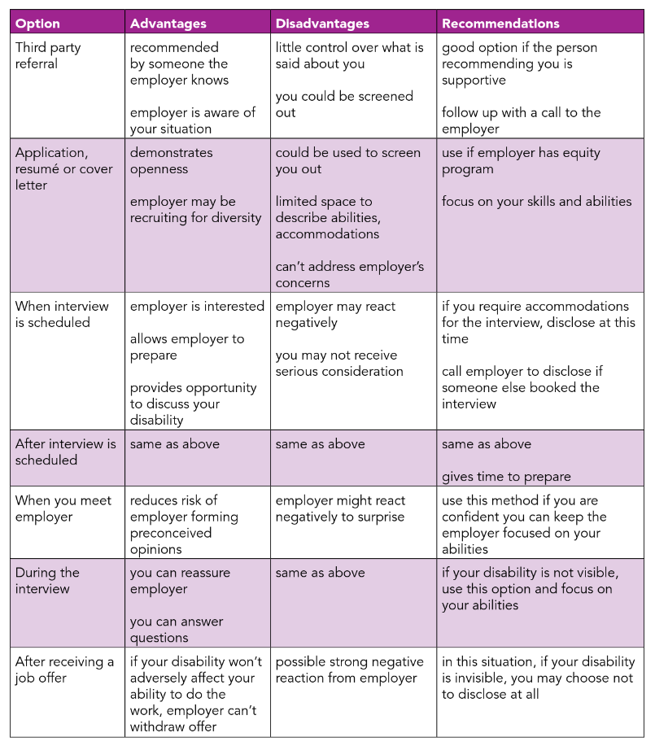

# Neurodiversity in the Workplace

We cannot make statements about whether neurodivergent colleagues are more or less productive than their neurotypical peers. Neurodiversity brings certain benefits and drawbacks to the workplace. How they are balanced is purely dependent on both the individual and their environment.

## Challenges

Sensory overload can impact well-being and productivity. Bright lights, noisy visual patterns, strong smells or changes in temperature can disturb neurodivergent people more than neurotypicals.

People of different neurotypes have a somewhat different way of communicating both facts and feelings. This can lead to communication gaps (both ways) when not addressed.

Depending on their neurotype, colleagues might prefer to work in teams, or solitary. A social environment can be very draining for, for example, some autistic people.

Neurodiversity often impacts the executive functioning. This makes certain tasks like time management or planning harder. Task or context switching could take longer and cost more energy.

## Benefits

Instead of personal opinions, let’s have a look at some quotes from the big players in the industry.

“Many people with neurological conditions such as autism spectrum disorder and dyslexia have extraordinary skills, including in pattern recognition, memory, and mathematics.”

- Harvard Business Review [9]

“When companies embrace neurodiversity, they gain competitive advantages in many areas — productivity, innovation, culture and talent retention, to name just a few. A report by JPMorgan Chase [found](https://www.ft.com/content/ea9ca374-6780-11ea-800d-da70cff6e4d3) in *Financial Times* (paywall) that professionals in its Autism at Work initiative made fewer errors and were 90% to 140% more productive than neurotypical employees.”

- Forbes [10]

“Organizations that make an extra effort to recruit, retain, and nurture neurodivergent workers can gain a competitive edge from increased diversity in skills, ways of thinking, and approaches to problem-solving.”

- Deloitte [11]

Neurodiversity is another type of diversity. It makes an organization stronger and more adaptive. Like any other diversity, it does need nurturing. We have to put in the work to reap the rewards.

# Taking Care of Neurodivergent Colleagues

## What is Disability?

The dictionary <https://www.merriam-webster.com> defines it as “a [...] condition that impairs, interferes with, or limits a person's ability to engage in certain tasks or actions [...]”. From a medical viewpoint, it is something inherent in a person, a deficit that might be cured or managed. From a social perspective, disability can be seen as an effect of interactions with our environment, as a power imbalance between differently-abled people. Neurodivergence falls, for the most part, into the social model of disability.

Disability is thus a product of societal barriers we create. This is not our fault, as we are shaped by our culture and environment. *We can, however, take those barriers away again,* which gives us the power to enable our peers.

Our neurodivergent colleagues can be more sensitive to barriers in the workplace than our neurotypical ones. We can see them as canaries in a coal mine, as means to “take the temperature” of our ways of working. The barriers that bother them most will probably also hinder neurotypicals. Who would not like to have a quiet place to focus sometimes? Who would not benefit from clear, concise communication?

The aim is not to create special rules and accommodations for neurodivergent colleagues. It is to improve all of our lives.

## Taking Care of Everybody

Neurodivergent colleagues might have specific needs. If this is the case, hopefully they will tell you about them. However, not everyone will be outspoken about their neurodiversity, for the many reasons listed in the following paragraphs. So instead of only catering to the needs that our colleagues voice, we should also try to adopt general improvements to our communication, behavior and work culture. You don’t have to assume anything about your peers to be a supportive colleague and an efficient communicator. This list of recommendations [6] aims to help neurodivergent colleagues, but how would neurotypicals perceive those? Would they be disadvantaged? Supported? How do you perceive them for yourself?

* Guidelines for Interacting with People who are Neurodivergent
  + Be direct with your questions.
  + Communicate clearly and concisely.
  + Avoid jargon and slang terms.
  + Be patient and give the person time to respond.
  + Remain comfortable with breaks in conversation.
  + If you are asked to repeat a question, try to explain it in a different way.
  + It may be helpful to write information down or use images.
  + Look past the physical symptoms and behaviors and see the unique person inside.
  + Ignore repetitive behaviors as you would ignore someone twirling their hair with their fingers.
  + Always presume competence.
  + Talk to the person, not about the person. Just because a person may have challenges with communicating, does not mean they can't understand what you're saying.
  + Don't take it personally if a person responds to you bluntly or makes a frank comment. Respond in a straightforward manner that explains why the response was inappropriate and give them a specific example of a more appropriate response

## Invisibility of Disability

There are many reasons your own neurodiversity could be invisible even to yourself.

### Lack of Knowledge

Our social environment shapes our self-image. We tend to surround ourselves with people who we feel comfortable with, with whom we feel at ease interacting with. Neurodivergent people might surround themselves with like-minded people, not realizing that a large part of the population thinks and behaves a bit differently.

If a person does not know they are on the spectrum, they cannot communicate it to their environment. Certain needs tied to their neurotype might not be obvious to them.

### Masking

Neurodivergent people usually hide their condition from the outside world, knowingly or unknowingly, to fit in. This is a coping mechanism to be able to function in an environment that does not play into the way their brain works.

This process of acting or suppressing urges costs energy and causes stress which can impact mental and physical health, especially if strategies to recover and recharge batteries are not developed yet.

### Nature of the Condition

Some disorders have little to no visible symptoms. The struggle of a mind working differently or translating between the outside world and the inside world is purely internal. This is exacerbated by masking.

### Stereotypes

The representation of neurodivergence in movies, books or other media is often skewed. We might imagine an autistic person to be a white male. People of color and women are often underdiagnosed for many kinds of disorders. Autistic people are seen as socially awkward and maybe gifted in some way. And yet, some autistic people are very sociable and have especially high empathy. Some people with ADHD appear very calm from the outside. The unrest is in their mind, not their bodies. This “inattentive” type of ADHD is also the dominant type in women, adding to their struggle to get a diagnosis or recognizing the condition in the first place.

### Stigma

Even when colleagues suspect or know that they are on a spectrum, they still might want to hide it. They might reject the image that comes with a certain label, or they fear that they would be seen as “less”, instead of different. Neurodiversity often impacts the executive function, making certain tasks harder or take more time than it would for their neurotypical colleagues. The benefit that their neurodiversity could bring to the table (e.g. thinking differently, pattern recognition, hyperfocus, memorizing, etc.) might (under? over?) compensate for an impacted executive function. And yet there is still the fear that it would be perceived as a weakness.

Colleagues on temporary contracts trying to get permanent employment, or for colleagues who aim for a promotion would be especially sensitive to how their performance is perceived. The same holds true for colleagues who are dependent on the income or have their residence permit tied to having a job. Regardless of whether this fear is justified or not, it is no surprise that they would hide their conditions when the stakes are that high.

## Practical Advice

Try to approach your colleagues from a place of curiosity. They might not be open to you about the way their brain works, but this is (most likely) not about you as a person. They could have their personal reasons to hide it, or they might be intimidated by (perceived) power differences between you.

If there are unmet expectations, there’s usually reasons for it, and laziness is not one of them [12]. Working harder does not solve the underlying issue, working smarter might. Finding the right approach to productivity can be challenging and it helps to have supportive, non-judgmental guidance. As an ally removing barriers, you can be an incredible multiplier. This way we can lean more strongly into the benefits that our neurodivergent colleagues bring to the table.

# Sources

[1] <https://www.health.harvard.edu/blog/what-is-neurodiversity-202111232645>

[2] <https://www.ncbi.nlm.nih.gov/pmc/articles/PMC7732033/>

[3] <https://mydisabilityjobs.com/statistics/neurodiversity-in-the-workplace>

[4] <https://www.techtalentcharter.co.uk/wp-content/uploads/diversity-in-tech-report-2024.pdf>

[5] <https://europa.eu/youreurope/business/human-resources/equal-treatment-qualifications/reasonable-accommodation/index_en.htm>

[6] <https://dam.assets.ohio.gov/image/upload/ood.ohio.gov/Literature/ERAH_Neurodiversity%20at%20Work_Learner's%20Guide.pdf>

[7] <https://www.mentra.com/top-ten-accommodations-for-neurodivergent>

[8] <https://disabilityalliancebc.org/wp-content/uploads/2017/06/DisclosureGuide.pdf>

[9] <https://imagine.jhu.edu/blog/2022/10/05/neurodivergence-at-a-glance/>

[10] <https://www.forbes.com/councils/forbeshumanresourcescouncil/2022/02/15/neurodiversity-and-the-workplace/>

[11] <https://www2.deloitte.com/us/en/insights/topics/talent/neurodiversity-in-the-workplace.html>

[12] <https://www.supersummary.com/laziness-does-not-exist/summary/>

## Books

* [Against Technoableism: Rethinking Who Needs Improvement](https://app.thestorygraph.com/books/e51570d8-8951-4166-bd50-58d94712dbf6)
* [Radical Inclusion: Seven Steps to Help You Create a More Just Workplace, Home, and World](https://app.thestorygraph.com/books/e811365d-01c8-4aa9-808c-1a4e3db56860)
* [Unmasking Autism: Discovering the New Faces of Neurodiversity](https://app.thestorygraph.com/books/7d14e30d-4181-45f6-8f23-72a448850a8a)
* [How to ADHD: An Insider's Guide to Working with Your Brain (Not Against It)](https://app.thestorygraph.com/books/b368b264-dfbf-459a-9f09-f0270b354b5d)

## Unsorted Information

For employers: <https://hbr.org/2024/03/an-employers-guide-to-supporting-workers-with-autism>

Good information from the NHS on Autism in the workplace: <https://www.leicspart.nhs.uk/autism-space/employment/reasonable-adjustments-at-work-autistic-people/>

